DYNAMIC RUNNING EVENT DESCRIPTIONS
January-December 2022
Dynamic Running offers a range of events that are open to everyone. You do not have to be a club member to compete or participate. Independent competitors pay higher race fees, so take advantage of the Early Bird discounts. LATE FEES and CUT OFF dates apply to ALL competitors, including Dynamic Running club members.
The information in this document is subject to change. Check our websites and Facebook pages for the latest updates.
Not a member? Sign up today via our website http://www.dynamicrunning.com.au/join/

Types of events
- Road
- Fun Runs
- Trail
- Training
- Socials and fundraisers – no running involved

ROAD
There are various road races and runs on offer throughout the year.
Road running include events on footpaths.
CLIFTON BEACH SERIES FOOT RACE/RUN | 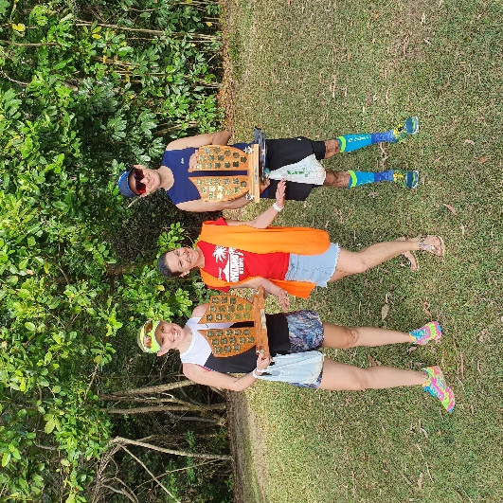  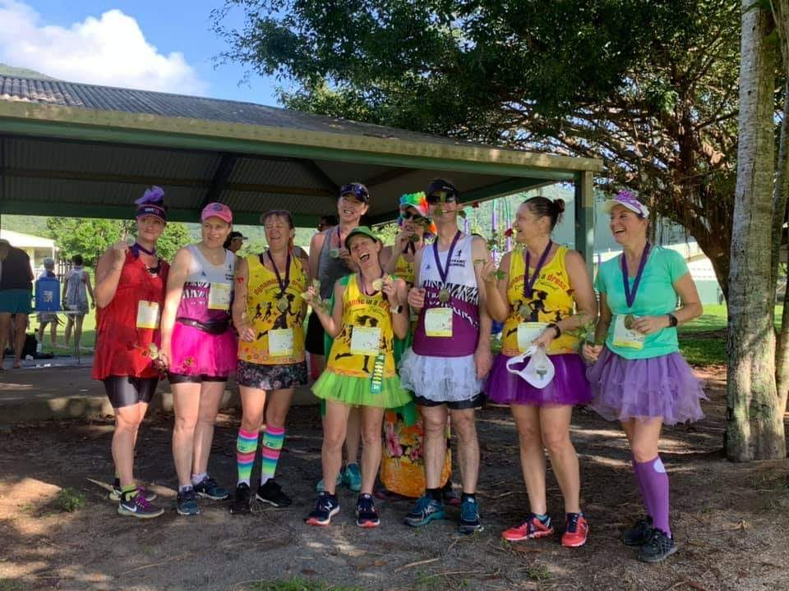
Race directors: TBC
Popular local race on the footpaths in Clifton Beach. 2 races in each series; 3 series events each year
Deadman’s Gully, Clifton Beach. MAP
Distance: 10km.

Series #3 (from 2021): Race 1 & Race 2
6.00am, 16 January and 13 February 2022

Series #1 Race 1 & Race 2
6.00am, 11 September and 9 October 2022

Series #2 Race 1 & Race 2
6.00am, 13 November and 11 December 2022

Dynamic in a Dress Running Festival
6.00am, 17 April 2022
Race director: TBC
Dress up in your tutu (yes, the boys do that too!) and run on footpaths adjacent to Freshwater Creek.
Redlynch State College, Redlynch Valley MAP
Distances: 10km and 21.1km.
Age restrictions apply to the races.
FUN RUNS  - RARE DISEASES FUN RUN/WALK, 27 February 2022  This is a Dynamic Running supported event.  - PAWS ON THE PATH, Sunday, 27 March 2022  Race director: TBC  Great morning out with your fur baby/babies whilst you support our local animal shelter, YAPS.  - ZONTA’S YELLOW ROSE FUN RUN/WALK, 15 May 2022  This is a Dynamic Running supported event.  - DOUGLAS DASH, Sunday, 22 May 2022. MAP  Race director: TBC  Urban trail run. The event is part of the Port Douglas Carnival and a fundraiser for TARC.  - CHRISTMAS LIGHTS RUN, Thursday, 22 December 2022 |  | 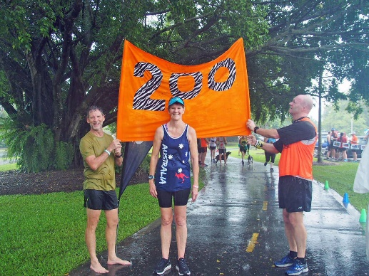

Join us for this fun FREE event! If you can't make it, you can register for the virtual option. MAP

PARKRUN
7.00am, each Saturday.
Event director: Steve Betesta
Fun ship on the Esplanade.
http://www.parkrun.com.au/register/
parkrun is a free, timed, 5km weekly event. Dynamic Running uses parkrun as a ‘club run’, monthly time trial and social catch up.

TRAIL
We have various trail races and runs throughout the year over varied terrain. Strict guidelines apply to junior runners.

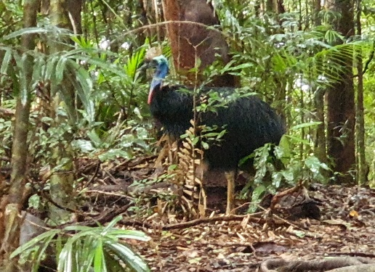

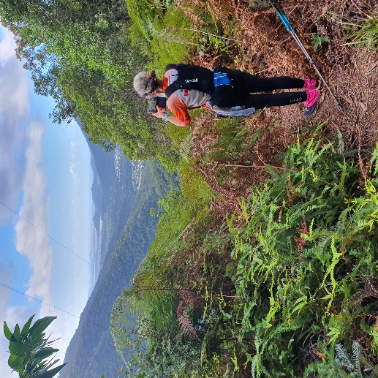

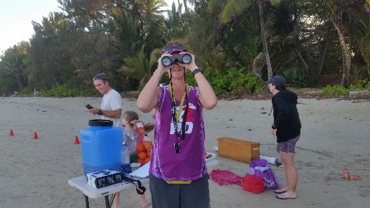

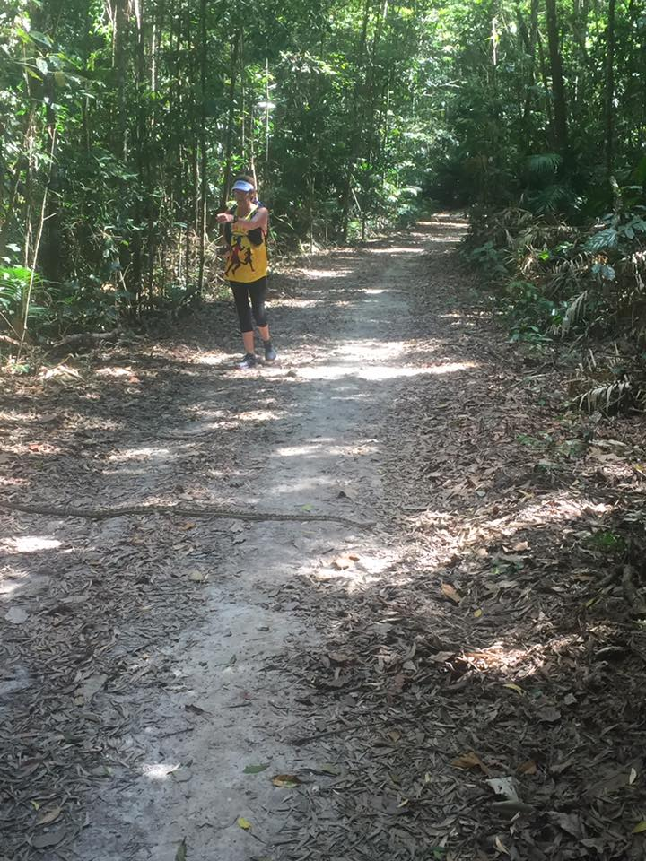

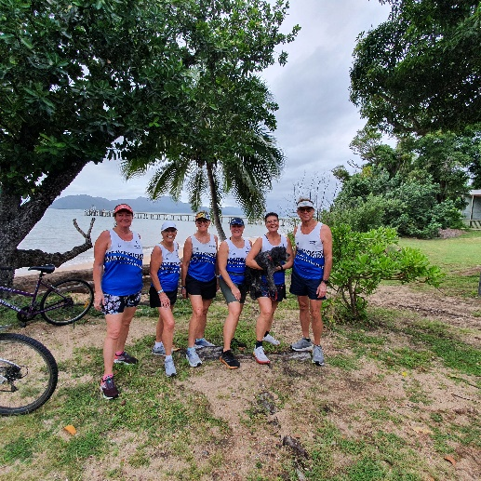

3 MARATHONS IN 3 DAYS
8-10 July 2022. Kuranda, Koah, Cairns MAP
Race director: Lorraine Lawson
There are four races on the same weekend and over the same course, but with varying distances. There are training runs during May and June that cover parts of the route. Transport is available at a nominal fee.
Early Bird entries end 27 March 2022.

3M3D races

11th 3M3D Grand Slam (18+)
6.30am, 8-10 July 2022. Kuranda, Koah, Barron Gorge National Park, Dinden National Forest, Cairns.
Premium 3-day staged race in tropical Far North Queensland, Australia. Hope you like hills! Competitors can opt to do 1, 2 or 3 marathons, but only those who complete all three marathons receive the coveted 3M3D medal. There is also the option to compete as a TEAM.

11th Cairns Marathon (18+)
6.30am, 10 July 2022. Koah, Dinden State Forest, Cairns.
Original and the best Cairns Marathon in tropical Far North Queensland.

2nd Fig Tree Half Marathon or 10km (16+)
6.30am, 9 July 2022. Kuranda, Barron Gorge National Park.
The Fig Tree Half Marathon replaces the Kauri Half Marathon because there has been a change in the course for Marathon 1 and Marathon 2. It is going to be a tough race through the tropical rainforest in Far North Queensland, Australia. On dirt with steep ascent and descent section.

4th Lake Morris Road Race (14+)
9.00am, 10 July 2021. Lake Morris to Cairns.
A 16km road race on Lake Morris Road from Copperlode Dam to Goomboora Park. Competitors can opt to be pacers for Grand Slam 3M3D or Cairns Marathon runners coming through the Copperlode Dam checkpoint.

12th KURANDA TO PORT DOUGLAS (K2PD)
7 August 2022.
Race director: TBC
MAP
Early Bird entries end on 24 April.

60km K2PD Ultra SOLO Trail Race (18+)
6.00am. Kuranda to Port Douglas.
Early starters set off at 5.00am.
This longest standing premier trail running event is incorporated in the Mowbray National Park within the Wet Tropics World Heritage Area. It starts just off Kennedy Highway in Kuranda and follows Black Mountain Road through native rainforest, open eucalyptus forest, pine plantations and over picturesque creeks. The finish is on Four Mile Beach, Port Douglas. The tropical rainforest is home to the endangered southern cassowary, a flightless bird that can grow to two metres in height - you might see one! Transport available.

60km K2PD Trail Relay (16+)
6.00am. Kuranda to Port Douglas.
Description as per the K2PD Ultra Race. Two to four runners are required per team. Juniors can only complete ONE of the four legs. Relay teams must provide their own transport.

DYNAMIC RUNNING MOUNTAIN TRAIL SERIES

Saddle Mountain Trail Race
7.00am, 21 August 2022. McGregor Road, Smithfield Conservation Park.
5km, 9km or 12km. MAP

Mt Baldy & Widow’s Peak Trail Race
7.00am, 28 August 2022. Mt Baldy walking track, Rifle Range Road, Atherton. 7km looped. MAP

Mt Edith Trail Race
7.00am, 25 September 2022. Davis Creek area. 15km or 30km. MAP

Misty Mountains Trail Race
7.00am, 23 October 2022. Misty Mountains. 10km, 21.1km or 42.2km MAP

TRAINING
Tuesday & Thursday training sessions
5.30-7.00pm, Greenslopes Street.
Long runs Sundays. Check our Facebook page for updates.

SOCIALS & MEETINGS
Dynamic Running Annual Members Meeting & 8th Anniversary Dinner 29 July 2022.

3M3D Buffet Meal 7 July 2022.

Club socials including fundraisers Suggest a theme and date!

Club meetings Various times throughout the year.

Contact Information
Managing director (April 2014 to current): Lorraine Lawson
Mobile: 0417 798 444
Email: info@dynamicrunning.com.au

Websites:
- www.dynamicrunning.com.au
- http://3marathonsin3days.com/
- https://info014874.wixsite.com/kurandatoportdouglas

Facebook pages:
- https://www.facebook.com/dynamicrunningaustralia
- https://www.facebook.com/3marathonsin3days
- https://www.facebook.com/kurandatoport/
Twitter: @dynamicrunning
Instagram: @dynamicrunning

